Sixth Grade Science Name_____________________
Unit 2 Posttest Study Guide

1. The surfaces of old concrete statues are often covered with small holes or pits. What causes this to happen?

The concrete is chemically weathered by acid rain.
2. What human activities can increase the rate of weathering?
Increasing the amount of acid rain, paving over large portions of land, Strip mining and agriculture

3. What human activities can help prevent soil erosion?
Crop rotation, terracing, and contour plowing and planting trees/plants

4. The dropping of sediments in a new place is called Deposition.
5. Over time, a rocky cliff will become many smaller rocks and eventually sand particles. This is due to which process?
Weathering

6a. Glaciers cause weathering and erosion. What are glaciers?
Giant mass of ice

b. What type of land formation do glaciers form?
U-shaped valley

7. What is erosion?
The movement of sediment from one place to another

8. The formation of soil is primarily the result of which two processes?

weathering and biological activity

9. Deltas are formed by deposition.

10. Fill out the table below using the word bank.
Word bank:
-ice wedging -abrasion by sand
-rocks tumbling in a river -acid rain
-oxidation or rusting -smaller pieces
-break down rocks - changes composition
-rocks tumbling down a hill and breaking

 | Mechanical | Chemical
Similarities | break down rocks
Differences | smaller pieces | changes composition
Water | rocks tumbling in a river | acid rain
Wind | abrasion by sand | oxidation or rusting
Ice | ice wedging | Does not break down chemically.
Gravity | rocks tumbling down a hill and breaking | Does not break down chemically.

11. A farmer is growing crops on a mountain in North Georgia. She notices that the soil and seeds erode downhill after every rainfall. Which would be the best soil conservation techniques to use, and why?
Terracing or contour plowing

12. What is the most important agent of chemical weathering to form a cave and why?
Water - It can carry acid and dissolve rock
13. Soil formation begins with the weathering of rock.

14. Sand dunes can be created over time from sand. Which agent of erosion most likely moves sand to create sand dunes?
wind
15. A student hiking in a rocky area on a mountain notices that wide, deep cracks have formed in some of the large rocks. Some of the cracks are so large that the rocks have broken apart. Which process most likely caused these rocks to crack and break?
Water freezing and thawing
16. Describe bedrock.
solid rock
17. During the early 1930’s, the “Dust Bowl” destroyed many farms. What was the main cause?
Bad farming practices and a long drought
18. The size and shape of a barrier island can change over time. Put an X by the items below that would affect the size and shape of a barrier island.
____The number of people who visit the mainland
__X__The number and height of tides along the shore
__X__The amount and size of sediments carried by the nearby rivers and streams
____The amount of hunting and fishing in the delta
__X__The number and size of waves from the ocean that reach the shore
____The bird species who live on the island
19. The decayed organic material in soil is called humus.
20. Soil is a mixture of what materials?

weathered rock, organic matter, air, water
21.
(Appalachian
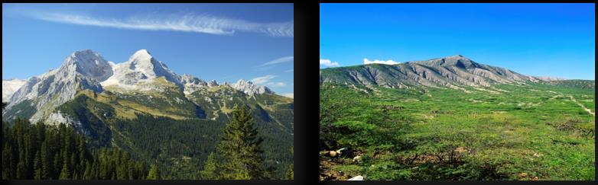
(Rocky Mountains) Mountains “back East”)

When Joe saw the Rocky Mountains for the first time, he exclaimed, "These mountains are much younger than ours back East!" Looking at the picture, which feature of the mountains supports his conclusion that the Rockies were relatively young mountains?
They have sharp peaks, and the Appalachian mountains have rounded tops
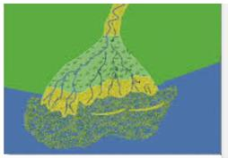
22. A type of landform shown is at the mouth of the Mississippi River. What is the landform called?
delta
23. Gravity is another force that contributes to erosion and weathering, especially when combined with slope. What could happen when gravity causes weathering and erosion?
Rocks and boulders sliding down mountainside resulting in a rock slide

24. Which agent of weathering and erosion is most likely responsible for shaping the Grand Canyon?
Water

25. It is the rainy season! Rivers are more muddy-looking during storms. Why does this happen? (List 3 reasons.)
Sediment builds up at on the river bottom and the river looks muddy, during a storm, a river is carrying a lot more sediment than during a low-flow period, fast-moving water can pick up, suspend, and move larger particles more easily than slow-moving waters

